Kairui Feng¹, Siyuan Xian¹, Ning Lin¹, and Mikhail V. Chester²
¹Department of Civil and Environmental Engineering, Princeton University
² Civil, Environmental, and Sustainable Engineering, Arizona State University

Many countries have pushed intervention policies to encourage electrical vehicles (EVs; Green et al. 2014), as they are energy efficient and are expected to become cheaper in the future (Needell et al. 2016). The US EV Everywhere Initiative, for instance, has a goal of producing EVs with sufficient range and fast-charging ability to “enable average Americans everywhere to meet their daily transportation needs more conveniently by 2022” (U.S. DOE, 2012). However, do we ever imagine that people might be trapped desperately in their EVs due to a power shortage when a natural disaster is happening? The recent catastrophic Hurricane Irma (2017) created the largest scale evacuation in Florida’s history, involving about 7 million people on mandatory evacuation orders and 10 million evacuation vehicles (The Two-way Radio 2017). If EVs were widely adopted, would evacuation on such a large scale challenge the power supply?

To investigate the viability and potential challenges of EVs for evacuation during disasters, here we estimate the electricity demand for Florida prior to Hurricane Irma’s landfall under the hypothetical condition that all evacuating vehicles were EVs and compare it with the estimated power constrain. Assuming that the evacuation process would be the same as the real case, we reconstruct the traffic flow during Hurricane Irma and estimated the charging time series for each evacuating EV (see Method). Summing up the estimated electricity demand from the evacuating EVs, we obtain the total electricity demand for each of the 10 power authority service areas in Florida (shown in Fig. 1). For each authority, the estimated EV electricity demand is added to the real inter-balance authority (BA) power demand inflow (blue curve in Fig. 1), to obtain the total power demand inflow (yellow curve in Fig. 1). The total power demand is compared with the power constrain estimated for each area (green line in Fig. 1). Based on current generation and transformation ability of America power network, the power constrain is estimated as 110% of the historical maximum inter-BA power flow (Albert et al. 2004) plus 20% of the maximum thermal power generation capability for each authority (considering the dispatch ability for different sources of energy). The generation ability of hydro and other types of power sources are not flexible under unexpected extreme power demand, so they are regarded as not reacting to the unexpected power demand. The shutdown of power generation stations including nuclear plants before hurricane landfall to reduce potential flood impact (Washington Post 2017) is also considered by a linear reduction on the power constraint.

As shown by the global electricity simulation result (Fig.1), the power failure shows significant pattern. The edging area including Homestead (HST) and Miami (FPL) shows no obvious overflow. This is because all the EV owners will pre-charge their cars before departure and they tend to drive a long distance to avoid the hurricane risk. As the main origins of the evacuation, the overflow pressure is not loaded there. This problem grows bigger when the exodus extended into inland Florida. All the companies are facing large electricity pressure and the EV power demand rapidly exceed the safety bar. The most severely afflicted areas would be Orlando and Ocala area with their local electricity retailers - Florida Municipal Power Pool (FMPP; ~400 Mw shortage) and Duke Energy Florida (FPC; ~1000 Mw shortage). Orlando, as a main tourism city in mid-Florida with plenty of hotels and shelters, welcomed ~ 700,000 cars a day during the evacuation peak for charging. This will ruin the whole power system in Orlando, leading to a secondary damage of hurricane. The local power network failure may lead to a larger scale cascading failure (Yang et al. 2017). As the bottleneck of Florida Power System, the failure of mid-Florida power network will cut the interconnection between Miami power network with Southern Company Services – the largest electricity provider for Florida if this happened in reality. As the only survivor of mid-Florida, the Gainesville Regional Utilities (GVL) escape this thanks to the limited householders (~20,000) they supporting comparing to other companies.

The peaks of power outage change both spatially and temporally. For Mid-Florida, the evacuation peak occurred at Sep. 8th. This fact led the power consumption peaks for them to be Sep. 7th and 8th. Then the evacuation peak came to North Florida at Sep. 9th , which makes the power outage in Florida lasts for an extra three days. This would badly effect the resilience of the power grid - even if the power grid at Mid-Florida had been repaired at the night of Sep. 8th, due to the power failure of North-Florida power grids, it will be separated from the eastern U.S. power grid again. This temporal peak character of evacuation would also be extended by the power grid failure – the one-day peak traffic at every location will trigger a 3-day long power outage peak over the whole Florida.

This simple analysis considers only the border (inter-BA) capacity and assumes that the inflow can reach wherever the electricity is needed. In reality, the spatial specifics of electricity supply and demand are critically important. Local capacity varies, power failures happen locally, and charging of EVs will happen in specific places. It is possible that EVs traveling along specific evacuation corridors may demand more electricity from the local network than there is the capacity to supply in those areas simulated to be safe here. And also, the catastrophic failure of the power network is not considered. The failure of local power network may trigger a large scale collapse of power grids over whole Florida and even threaten Georgia and Louisiana (Yang et al. 2017). From the perspective of public safety, substations and power lines must be able to provide enough electricity when large numbers of evacuees plug in, or large-scale or swappable batteries must be available. This raises serious questions about grid supply and investment and points to prioritization of future research to identify where to strategically invest in grid capacity to ensure that demand every when people are most vulnerable (i.e., during evacuations). Furthermore, it points to the need to identify evacuation charging strategies that ensure chargers, incentives, and management schemes are used during evacuations to ensure that those who need to evacuate can and those that are most vulnerable are prioritized. We must assume that with large-scale adoption of EVs the rules and behaviors that we’ve previously experienced with conventional vehicles no longer apply, and that we must start to understand the new rules that will govern EV use.

Here we also discover that a proper EV portion might weaken the gasoline shortage problem of evacuation. Florida was facing a larger gasoline shortage problem during last summer – 58% gasoline stations at Gainesville are out of gas, while 40% for Miami and 35% for Tampa and many people line up for hours to get the gasoline for evacuation (USA Today 2017). If the EV occupancy rate in Florida is raised to 35%, hopefully it will weaken gasoline shortage problem by a large portion and not affect the well-functioning of the power network (The lowest EV portion threshold for power outage occurrences is ~45% at FPC). This would possibly lead to additional traffic amount since more people might choose to evacuate before Irma because of the easier access to gasoline. On the other side, it would also increase the efficiency of evacuation because this might make large region all lanes one-way evacuation possible. One of the main concerns for Florida local government to open both sides of the highway for evacuation is that the counter side traffic is necessary for the supplement of gasoline (Miami Local News 2017). The most convincing way to combine the benefits of EV and normal vehicles under evacuation might be hybrid power. For a typical hybrid power vehicle, such as Chevrolet Volt 2018, it can drive on electricity for ~50 miles (13% total power) and on gasoline for ~350 miles (87% total power). The electricity capacity may increase its ability to search gasoline in a larger area. This concurs the problem of local gasoline shortage. And also, good gasoline-only endurance performance helps the government to manage the electricity resources. For the power grid, using as much hybrid vehicles as possible do no harm to the power network (13% is under the 45% threshold).

For conclusion, we argue that policy makers need to consider this evacuation problem when promoting EVs in certain regions. For hurricane risk zones such as Florida, specific charging strategies need to be developed to avoid large demand peaks during evacuation. Also, EVs may need to be equipped with batteries that would allow a higher travel range on a single charge – another motivation for developing new battery technology such as the solid-state battery (Motavalli, 2015). On the other side, the proper use of EV policy would be a powerful tool to release the gasoline pressure pre-hurricane and also, would help local government to develop more flexible and efficient policy to ease the traffic crisis.

Method
Although the traffic on main highways Florida are recorded during Irma evacuation, the local highways have no data available, which may lead to a large bias of traffic ammount. To solve this problem, Feng and Lin (2018) estimated the traffic demand for Florida highways (speed limit≥ 35 mph) during Hurricane Irma, using partial observations and the game-theory-based user equilibrium assignment model. Based on traffic demand estimation, we reconstruct the evacuation traffic time series for each highway in Florida during Irma. To do so, we trace each evacuating vehicle through an agent-based approach. At each time step, a certain number of vehicles go out of one place and head to another place, according to the traffic demand. Some of them have already evacuated from other places (with reduced battery power) and others are local (starting with full battery power). To differentiate them, we assume that the evacuating portions of local and incoming vehicles are determined by whether the incomers can find shelters or hotels. When the local shelters and hotels (TCpalm 2017, STR 2017) become full, new incomers have to keep going and occupy part of outgoing evacuation flow. The other part of the evacuation flow is uniformly distributed to the local, now including the accommodated incomers.

Based on the reconstructed traffic time series, the battery power usage for each evacuating EV is estimated. All vehicles follow the Tesla Model 3 EV electricity consumption benchmark (Tesla Main Page 2017). The electricity consumption also changes with traffic speed – from 340 Wh/mile at 60 mile/h (maximum range 250 miles) to 600 Wh/mile at 5 mile/h (maximum range 150 miles) – due to both frequent stops and air-condition needs (Beijing Time 2017). We assume that the vehicles recharge (to full capacity) immediately when they leave a highway and stay in a city. We also assume that all the vehicles have to stop and recharge when their battery level is lower than 20% of the capacity. In reality, the charging schedule may impede one’s original evacuation plan, but in this analysis, we simply assume the charging pattern is independent of the evacuation process.

References:
Florida Department of Transportation 2017: http://www3.dot.state.fl.us/trafficinformation/ last visited at: 2017-12-06

Green, E. H., Skerlos, S. J., & Winebrake, J. J. (2014). Increasing electric vehicle policy efficiency and effectiveness by reducing mainstream market bias. Energy Policy, 65, 562–566. https://doi.org/10.1016/j.enpol.2013.10.024

Motavalli, J. (2015). Technology: A solid future. Nature, 526, S96-S97.

Needell, Z. A., McNerney, J., Chang, M. T., & Trancik, J. E. (2016). Potential for widespread electrification of personal vehicle travel in the United States. Nature Energy, 1(9). https://doi.org/10.1038/nenergy.2016.112

Tesla Main Page 2017: https://www.tesla.com/models last visited at: 2017-12-06

The Two-way Radio 2017: https://www.npr.org/sections/thetwo-way/2017/09/09/549704585/-the-storm-is-here-floridians-window-to-evacuate-shrinks-as-irma-bears-down last visited at: 2017-12-06

U.S. DOE, 2012. President Obama Launches EV-Everywhere Challenge as Part of Energy Department's Clean Energy Grand Challenges. United States Department of Energy, Washington, D.C.

U.S. Energy Information Administration (EIA) 2017: https://www.eia.gov/ last visited at: 2017-12-06

Washington Post 2017:https://www.washingtonpost.com/news/energy-environment/wp/2017/09/08/florida-nuclear-plants-could-take-a-direct-hit-from-hurricane-irma-plant-owners-say-they-are-ready/?utm_term=.112e026dca1b last visited at: 2017-12-06

Ennio Cascetta, Domenico Inaudi, & Gérald Marquis, (1993) Dynamic Estimators of Origin-Destination Matrices Using Traffic Counts. Transportation Science 27(4):363-373. https://doi.org/10.1287/trsc.27.4.363

Robinson, A. P., Blythe, P. T., Bell, M. C., Hübner, Y., & Hill, G. A. (2013). Analysis of electric vehicle driver recharging demand profiles and subsequent impacts on the carbon content of electric vehicle trips. Energy Policy, 61, 337-348.
PDC Power delivery consultants Cables Standard 2018: http://www.pdc-cables.com/oh_limits_powerflow.pdf last visited at: 2018-02-11

TCPalm 2017, http://data.tcpalm.com/storm-shelters/

STR2017, https://www.strglobal.com

Beijing Time 2017, https://item.btime.com/m_2s1cm7gfu25

Albert, Réka, István Albert, and Gary L. Nakarado. "Structural vulnerability of the North American power grid." Physical review E 69.2 (2004): 025103.

USA Today 2017, https://www.usatoday.com/story/money/2017/09/08/hurricane-irma-gas-shortages-florida/645747001/

Miami Local News 2017,https://www.miamiherald.com/news/weather/hurricane/article172000577.html
Yang, Y., Nishikawa, T., & Motter, A. E. (2017). Small vulnerable sets determine large network cascades in power grids. Science, 358(6365). Retrieved from http://science.sciencemag.org/content/358/6365/eaan3184.abstract

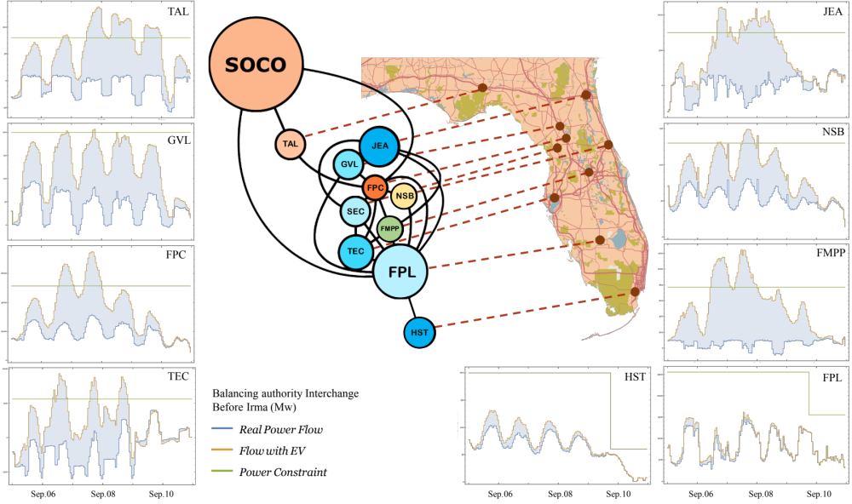
Fig 1. Inter-balancing authority (BA) power demand inflow to Florida prior to Hurricane Irma’s landfall (on Sep 11, 2017): Real electricity demand inflow (blue curve; data obtained from EIA 2017), synthetic 100% EV scenario electricity demand inflow (orange curve; estimated), and the power bottleneck constraint (green curve; data obtained from EIA 2017).

